Accessible Mail

TU Dortmund University, Germany

Supervisor
Michael Schaten

Team Students / Developers & Background
Demming, Simon (Team Contact Person), BA Computer Science (6th Semester)
Langenberg, Jonas, BA Computer Science (7th Semester)
Hesse, Stefan, BA Computer Science (6th Semester)
Goldap, Phillip, BA Computer Science (6th Semester)

Abstract

Target Groups
Partially sighted persons, Persons with cognitive and learning disabilities, Persons with mobility disabilities, elderly persons, Persons with limited technical knowledge

Problem / Situation Addressed
E-mail is the most important application to exchange information among internet users. Most web clients of e-mail service providers show a complex user interface design and cause technical problems due to non-standard or browser-specific implementations (e.g. Flash or JavaScript).

Challenge Factors & Impact
The resulting product is intended to fulfill the principles of universal design and to allow all people access to e-mail. Usage should be possible even if the providers’ webmail interface is hard to understand or use and independent from a certain disability (e.g. visual or hearing).

State of the Art & Other Approaches
Web interfaces of e-mail providers are typically overwhelming due to their offered functionality and design and in conclusion they are not user-friendly. Furthermore they do not consist of any alternative options or help addressing the specific needs of people with disabilities.

New Ideas & Developments planned / implemented
The intended application allows users to easily manage various e-mail accounts in parallel and an address book of their contacts. The software development contains ongoing user tests (User Centered Design) and focusses on addressing the principles of a Universal Design allowing anyone using the software.

Framework (not more than 250 words)

Project Schedule (When to do what, who and how)
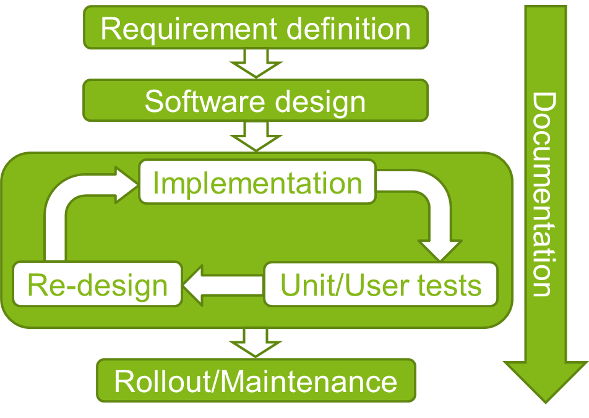
The software development follows the typical structure of software engineering with different phases included. In the first step the basic software requirements are defined. Following a first prototype software architecture including first ideas about the graphic user interface (GUI) is designed. These considerations are then implemented in source code and continuously evaluated in unit and user tests. New insights resulting from these tests will be addressed in a re-design and re-implementation of the existing software. Hence, the software development takes place as an iterative process. After finishing the development, the software will be distributed via github and further maintained. All different phases are documented simultaneously during the development.
The project plan emphasizes both, flexibility and exchange with potential future users. Flexibility is relevant since all participating students ought to study besides working on the project. The user involvement on the other hand is important to design the software such that it meets the users’ requirements optimally.
A lot of functionality needs to be implemented: The contact list of associated names, addresses and other details, functions to import/export contacts from or to other sources in a standardized format, the communication protocols between the mail client software and different mail servers via SMTP/IMAP/POP3, the data model and, most importantly, the graphical user interface (GUI). Two students are responsible for designing and implementing the GUI, while the other two focus on the “non-visual” parts of the software.

Platform / Infrastructure / Manpower used / serviced
The version control used is git with a server available from github. Communication among the team is based on e-mail, Skype conferences and regularly personal meetings. Python has been chosen as programming language. Compilers are available for many different operating systems. Hence, the resulting software can be used in various environments.

Validation / User Involvement and Sustainability (not more than 250 words)

Testing routines
Unit tests ensure the program’s functionality. Tests executed by friends and family will give an objective view on the software’s usability. In addition the project team plans to test the software together with people with different disabilities, including e.g. low vision, learning disabilities and motor impairment.
Each test person is asked to complete a set of tasks defined in a test script. While working on this task list the testers are accompanied by a member of the development team who observes the tester’s usage behavior and discusses different aspects of the software with her/him. Observations and tester’s remarks are registered and analyzed after the tests have been finished. The standardized approach allows comparing and interpreting the different results objectively. The resulting insights then form the base for the further development in a following iteration circle of the software implementation.

User involvement
The project follows a User Centered Design approach (see section “Testing routines”). Hence, the interaction with potential future users already during the software development phase is crucial for this project. The project team is in contact with different stakeholders in the field of rehabilitation and education in Germany to acquire several testers covering the various types of disability.

Sustainability
The software is written in Python and makes use of the kivy framework. Both elements are quite popular nowadays and it is to expect that they will be further maintained by their individual community in the future.
After finishing the “Accessible Mail” project, the resulting application including its source code will be published via github under General Public License (GPL, open source). Hence, everybody interested is allowed to contribute to the project and to elaborate it any further. In addition, the kivy framework allows configuring the application for mobile devices. Therefore distributing the software via different app-stores (e.g. Google Play Store) is possible as well.

